Speed of Sound

PHYS 211L – H02

Tuesday 10:05am – 12:05pm

Abstract

In this lab, we determined the speed of sound in air at room temperature using a resonating air column. We adjusted the length of the air column and found various resonance lengths, and from out measurements, we found that the speed of sound in air at room temperature is 347.1 m/s.

Introduction/Background

While the speed of light and sound are both absurdly fast and seemingly reach your ears and eyes instantaneously, they do have a measurable speed. In the correct conditions, we can see that these two speeds are indeed different. As it turns out, the speed of light knocks the speed of sound out of the water. But how do we measure the speed of sound?

The first person to attempt to measure the speed of sound was [1] Pierre Gassendi in 1635. For his calculations, he measured the time difference between the explosion of a cannon and the arrival of the sound from a distance. His measurements, for how primitive they were, were extremely accurate and resulted in a calculation within 0.5 meters per second of the actual speed.

However, in our experiment, and in most modern measurements, our calculations used waves to determine the speed of sound. Because we know the frequency of the wavelengths created by the tuning fork, we can use the formula **.** Measuring several distances of tubing to search for a resonance frequency allows us to determine a wavelength to use in our formula. Help he has a gun

Procedure

Materials used: Tube, clamps, flexible tubing, water, a thermometer, water jug, meter stick, and two tuning forks.

First, we recorded the temperature of the room, which was 26°C. Then, we recorded the radius of the tube, which was 0.015 meters.

We filled the tube with water and then struck one of the tuning forks against the heel of someone’s hand. While holding the tuning fork approximately two centimeters from the open end of the tube with the tines perpendicular to tube’s axis, we began adjusting the water level, thus increasing the length of the air column. While doing this, we listened for sudden increases in sound intensity and, when found, we marked their location by placing a rubber band around the tube at the height of the water and measured that distance from the top of the tube. We did this two more times and then repeated the process with the other tuning fork.

FOOKIN DIAGRAM

Clamps

Water Jug with Water

Tube with Water

Meter Stick

Flexible Tubing

Results/Analysis/Physics

There’s sum fisiks n stuff – seems kewl

Measurements

|  |  |  |  |
| --- | --- | --- | --- |
| Tuning Fork 1 Resonance Lengths (m) | Tuning Fork 1 Wavelengths (m) | Tuning Fork 2 Resonance Lengths (m) | Tuning Fork 2 Wavelengths (m) |
| 0.168 | 0.708 | 0.14 | 0.596 |
| 0.52 | 2.116 | 0.43 | 1.756 |
| 1.04 | 4.196 | 0.83 | 3.356 |

Frequencies

|  |  |
| --- | --- |
| Tuning Fork 1 (Hz) | Tuning Fork 2 (Hz) |
| 490.254 | 582.383 |
| 164.036 | 197.665 |
| 82.722 | 103.504 |

Graph of Frequency vs. 1/Wavelength

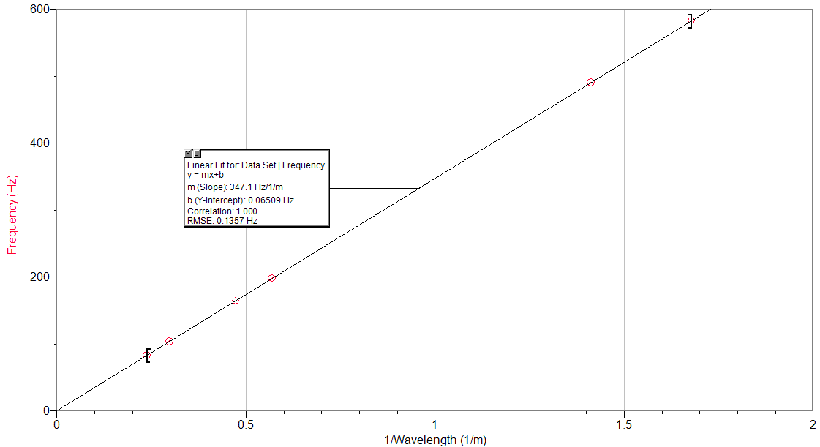

Conclusion

[*What was* learned] From this experiment, we were able determine what the speed of sound is in room temperature conditions. This lab proves that the formula for the speed of a wave, **,** is applicable in a real-life setting. Because we know the frequency of the sound wave due to the properties of our tuning fork, determining wavelength allows us to find the velocity of the wave. Resonance occurs when the antinode of the sound wave aligns with the end of the tube and can be observed by an increase in the volume of the sound made by the tuning fork held over the tube. By consistently altering the effective length of the tube using water and gravitational potential, we can listen for a fluctuation in the volume of the sound. By finding other tube lengths that result in resonance, we can compare these to determine a wavelength and thus solve for the velocity. [*Uncertainties*] The sources of uncertainty in this experiment are the result of unideal conditions. Being able to hear the slight increase in volume during resonance was *extremely* difficult in a loud classroom setting. This resulted in many failed trials and the necessity of repeated results beyond the normal. Slight fluctuations in temperature could have also impacted the results of our data as people move around and increase the temperature in the classroom or the air conditioning turns on and decreases it.

[*First Universal Question*] Our data was relatively accurate to the expected results given our circumstances and the conditions of our experiment. We were able to observe results with a <1% inaccuracy to the known speed of sound in room temperature with a speed of 347.1 m/s where we expected 343 m/s. [*Second Universal Question*] The idea that speed has a certain speed through air is present every time you open your mouth to speak. Although almost imperceptible, there is an ever-so-brief delay between when someone speaks and when the listener hears. At such a close distance, this time frame is basically negligible. When we can get a better understanding of the speed of sound is on the Fourth of July. When you observe fireworks from a significant distance, you are able to perceive the firework’s shape, light, and color, but not sound until after a small instance of time.

Lab Questions

2. From the slope of the graph, we found that the speed of sound is 347.1 m/s. From the given formula v(T) = (331.5 +0.6T), and from our measured value of T = 26°C, we found that v = 347.1 m/s. These values are identical.

3. The speed of sound in air decreases as the temperature decreases. Our measurements would change to reflect this. How exactly would they change? I think that our measurements of where we found resonance would be further apart since there is a longer wavelength because of the formula ¯\_(ツ)_/¯

4. Well, I guess you’d be finding the speed of sound in water instead of air. That would probably change some things. Well, I guess since we know that sound travels faster in water, and we know the frequency of the tuning fork won’t change, the wavelength must decrease. My guess is that the measurements of the resonance points will be closer together.

5. Well if you’re on the Moon you’re certainly not finding the speed of sound in air. Or maybe you are and I’m somehow that dumb. If you’re doing this experiment on the moon, I don’t think you’re qualified to be on the moon. I hope the astronaut cracks his helmet with the tuning fork so he can’t reproduce.

References

1. Megraw, Stan. "How Did Scientists Figure out the Speed of Sound and Light?" CurioCity. N.p., 23 Jan. 2012. Web. 14 Nov. 2016. <https://explorecuriocity.org/Explore/ArticleId/187/how-did-scientists-figure-out-the-speed-of-sound-and-light-187.aspx>.